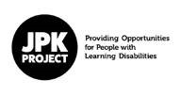

**NEWSLETTER**

**JANUARY 2025**

**Patron: Dame Jane Gow DBE**

**Sponsored by: Ann and Robert Lindsay**



**“How many difficult roads has the JPK travelled over the last 20 years, to be able to succeed with our dreams to develop a Supported Living Centre for people with a learning disability? Not enough fingers on our hands to count, with many roads blocked to us by opposition, bureaucracy and financial difficulties due to the economic climate over the last few years.**

**However, there have been so many people who have kept faith in our ethos and aims and objectives, which has meant that our dreams have now become a reality and we have reached our ‘ beautiful destination’.**

**GOW LODGE – Supported Living Accommodation:**

The Official Opening was held on the 14th September 2023 by the Lord Lieutenant of East Sussex, Andrew Blackman, in the presence of the Worshipful the Mayor, Cllr Candy Vaughan, honoured guests, donors, friends, supporters, students and future tenants and families.

Since then Gow Lodge has gone from strength to strength with a full complement of 7 tenants, supported by an excellent MyPesp staff team.

Since then there has developed a very happy and active relationship between all the tenants, which is a joy to see and everyone has gradually taken to their ‘new lives’ with all the new activities and opportunities of their choosing and already have developed much more independence.

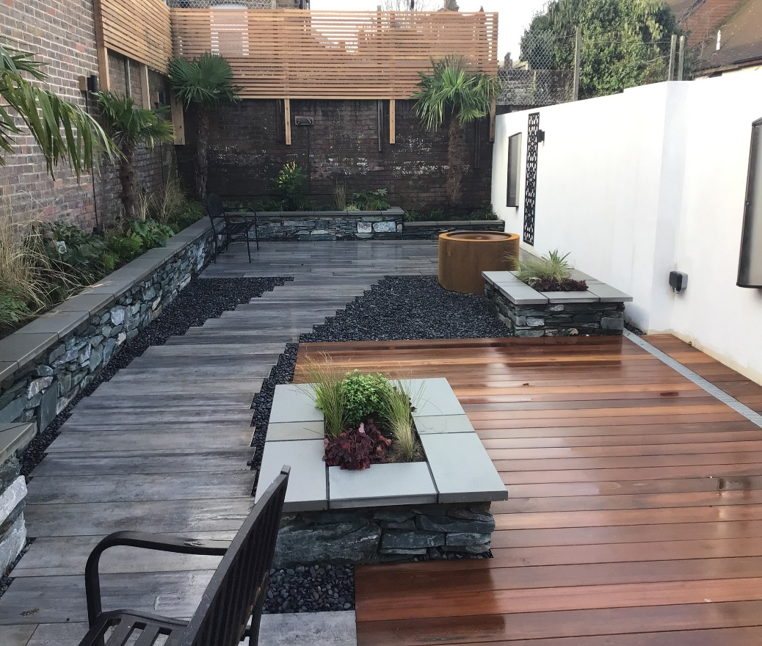**The Garden** has been developed and completed, which has led to more opportunities for outdoor relaxation and socialization, not only amongst themselves, but to include family and friends. You will note that there are foldaway washing lines.

Garden Furniture has been purchased and the Official Opening was held in September 2024 by Cllr John Pritchett, Willingdon and Jevington Parish Council in the company of guests, donors, tenants and families.

Refreshments were provided with a BBQ undertaken by Maureen and John Males, ably assisted by Patrick and Fr Kevin. The event was enjoyed by all on a beautiful sunny day.

**New Car – Citroen Berlingo:** At the same time the new car

was delivered by Wilmoth’s of Willingdon, which concluded all the major fundraising at this stage. The car will be used solely for the residents of Gow Lodge to enable the tenant’s access to the community for essential journeys eg: medical appointments, external activities, shopping and visiting family and friends, when required.

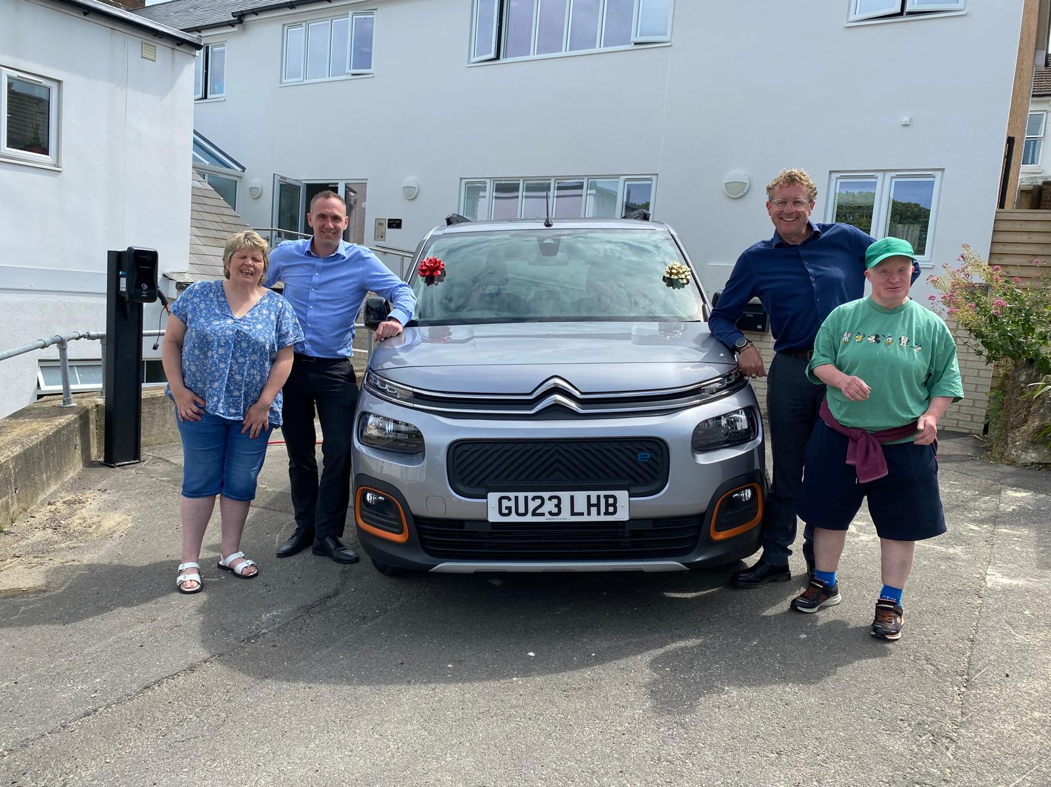

**None of the above could have been achieved without the support of so many people – too many to name!**

**The Trustees have worked tirelessly over the last 20 years and we are grateful for their endeavour to reach this ‘end game’!**

**Our grateful thanks to everyone who has supported the JPK, not only financially, but with their faith and time, in our endeavours.**

**THE COMMUNITY TRAINING CENTRE: (CTC) Old Town Cafe: (OTC)**

It is not all good news as sadly the Trustees had to made the unenviable decision to close the CTC in January 2024. Not on a whim, but because it had been running at a loss for over 2 years. Hospitality was having a tough time during the pandemic and post pandemic era, due to having to close periodically, and customers really never picked up, with the added burden of rising utility bills and food prices. It certainly was sad to say farewell to our Students and Staff. The Students had all achieved many skills and grown in confidence and independence during their training at the JPK.

‘Every cloud does have a silver lining’ and whilst we were making alternative plans for the CTC, we were approached by Rom Sanglagi, CEO, SASBAH. A very long-standing and successful charity were having to leave their current premises and were urgently seeking a new location. The JPK ‘fitted the bill’ and after several discussions, in January 2025 they moved into the CTC area.

SASBAH was set up by families in 1965 for people in Sussex affected by spina bifida, hydrocephalus and other disabilities. SASBAH offers support, skills and opportunities to live a full and happy life. Working together with their community they create high quality options to meet the individual need of their service users.

*They remain the only organisation in Sussex able to provide a range of condition- specific services and are unique in committing to support people for their entire life.*

They joined with us for the JPK Christmas Party, which was a great success, enjoyed by all and we all look forward to an exciting and productive working relationship. For further information contact: [rom@sasbah.org.uk](mailto:rom@sasbah.org.uk)

**PATRON:**

Dame Jane Gow DBE continues to be our Patron and we are grateful for her continued interest, support and advice.

She is looking forward to visiting the JPK in the Spring to see all the achievements since her last visit.

**TRUSTEES:**

The Trustees have continued to work tirelessly behind the scenes and we are pleased to announce that we have been able to recruit 6 new Trustees. The full complement is now:

Kelsey Broughton

Jill Parker – Chairman - Secretary

Warren Poll

Fay Price – Treasurer

Cheryl Priscott

Greg Priscott

Luke Watts

Cris Haniver retired in February 2024 after many years of service. We thank her for her time, advice and friendship during the period.

**OBITUARY**

It is with great sadness that we have to announce that Dr Patrick Parker, General Practitioner ‘sailed away on his final journey’ on the 1st September 2024, following a tragic accident.

Patrick became a Trustee and a Director to the JPK Sussex Project in 2009, at the first inception of it becoming a new charity, when only ‘a dream’, for a future Supported Living Centre for people with a learning disability. He has always been a loyal and constant Trustee and we have always valued his wise advice, practical hard work, fundraising and enjoyed his sense of humour, throughout the last 15 years.

He was able to see Gow Lodge completed and his daughter Katie happily living there with her new friends and staff to support her.

He will be sorely missed by his family and friends.

“The world is a better place because he was”.

**FUNDRAISING AND DONATIONS:**

**Grants:**

Lady Ratlings – Cup of Kindness £1,165.00 Car Charger

Bernard Sunley Foundation £5,000.00 Car

Beatrice Laing Trust £5,000.00 Car

Willingdon & Jevington Parish Council £2,000.00 Garden

Charlotte Marshall Charitable Trust £ 431.98 CTC

Anne Harvey – Legacy £5,000.00 Gow Lodge

**Further Donations:**

P Parker JM Bevan BA Sinclair

CF Morley P&D Siggs J&T Dunford

ED Houghton N Page S Smith

S Harvey Just Giving East Dean&Friston

J Parker Rotary Club EBC Lottery

Give as your Live T Deadman PM Cantwell

TG Clark I Kitt Utility Warehouse

N&M Clive Matthews J Guthrie M Fusiarska

M Miller Clients Deposit PA Adlam

A&C Whatford Dame Jane Gow R Green

Brewers Easy Fundraising Victoria Baptist Church

R&J Laughton PCC Harrietsham Polegate U R Church

S Barrow H E Harries S Anderson

H Gibson Micheldene WI Seaford Nat Trust Assoc

E/B Open Bowls Tournament

In Memory of Patrick Parker £2,366.37 Solar Panels Fund

Our very grateful thanks to all those that have donated during this last period. Your generous donations have made everything possible.

**JPK Collecting Tins:**

The Triangle CooP £270.45

Anne Lindsay £ 2.43 Margaret and Mavis - £114.50

Eastbourne Open Bowls £70.00

**HMRC – Gift Aid:**

On the 16th April 2024 the JPK received £13,666.91 following the filing of all donations for the JPK received during the year of 2023-2024.

This was a wonderful bonus and our grateful thanks to all those that subscribe to be eligible for Gift Aid and those that donate to our Collecting Tins. ***It all makes a difference.***

**FUNCTIONS AND FUNDRAISING:**

**The JPK and SASBAH Christmas Party** was held on Friday, 13th December 2024 to a full house, with a wonderful buffet supper, arranged by SASBAH and dancing all evening to Steve’s Tropical Disco. Father Christmas made an early visit with gifts and he was welcomed by all with great excitement.

**The JPK Annual General Meeting** was held on Tuesday, 14th January 2025. All documents have been filed to Companies House and the Charity Commission.

Our grateful thanks to Fay Price for undertaking the Accounts which were sent to John Males, Watson Accountants for completion.

Our very grateful thanks to John, who once again this year finalized the Accounts as a pro bono donation.

**FUTURE FUNDRAISING EVENTS:**

* **SASBAH CHARITY DINNER on Saturday, 22nd March 2025 at 7pm at The View Hotel, Grand Parade, Eastbourne.**

There is a 3 Course dinner, entertainment, disco and charity raffle

Tickets £35 ph or a table of 10 for £315.

For more information telephone 01825 873045/07779038542 or email rom@sasbah.org.uk.

**SUPPORT INFORMATION:**

**Easy Fundraising Website:**

If you shop on line, you can also donate to the JPK by registering with http://www.easyfundraising.org.uk/find-a-cause and select JPK Project. In the search box enter **JPK** – click on **support this cause** and set up the account. A wide range of outlets such as Amazon and John Lewis etc will donate a small % of the purchase price. It doesn’t cost you anything but benefits the JPK.

**Give as you Live:**

This site was brought to our attention recently by one of our supporters as being another avenue of fundraising when using ‘on line’ shopping. Thank you. It costs the JPK and you nothing. Bonus!

**UW Customer Donations:** Everyone who receives their utilities from Utility Warehouse can nominate a charity to benefit and the JPK receive a donation on a monthly basis.

**Used Stamps:**

Una Genty continues to collect used stamps from all and sundry and has recently completed a full bag to send off, whereby we should be receiving a cheque shortly.

Do continue to collect your stamps for us and they can be delivered to Una, if you know her address, through the letterbox at the JPK – Old Town Café- or to Jill.

**Eastbourne Lottery:**

The JPK has subscribed for many years to the Eastbourne Lottery and we continue to subscribe and are extremely grateful to all those that have purchased tickets on behalf of the JPK. We receive periodic donations from this source for which we welcome and are grateful.

**Data Protection:**

Should you no longer wish to be on our mailing list for Newsletters or Information, either by email or ‘snail mail’, please contact us and we will delete your contact details from our database. May I assure you that we never pass on any contact details without your personal confirmation that we may so do.

**Marketing/Website:**

* **Marketing.** Currently we have no one helping us in this department. Should you know of anyone who could spare an hour or two regarding this issue, please do not hesitate to contact Jill.
* **Website:** Regretfully, for several months we have been without a website, as it was illegally removed. However, we are now grateful to Jason Ansell, from MyPesp who has designed a completely new website which I believe is very up to date and refreshing. I still have some more information to add, when I have a moment to spare, but it is a wonderful start.

**Graphic Design:**

Mick Cooke continues to assist the JPK with all our graphic design when required for posters, fliers, invitations and tickets and everything I ask of him on a voluntary basis. He also comes up with some brilliant ideas, from time to time, for raising the profile of the JPK. Thank you Mick for you longstanding and continuing support.

**IN SUMMARY AND CONCLUSION:**

As per usual the period of this Newsletter has had its ups and downs, but in the main it has been very successful, with having completed Gow Lodge, the Garden and the purchase of the Car.

New Trustees have become involved and learning ‘the ropes’ of managing a Charity and we are all planning the future way forward for the JPK.

We are all delighted to have welcomed SASBAH and are looking forward to a future in partnership, whereby, along with MyPesp, we can improve the lives and support those with a learning disability and their families into the future.

We would welcome your continuing support. Our work is not done and together we can still achieve and ‘improve the lives of those who,

through no fault of their own, cannot help themselves’.

***Jill Parker MBE Chairman and Editor***