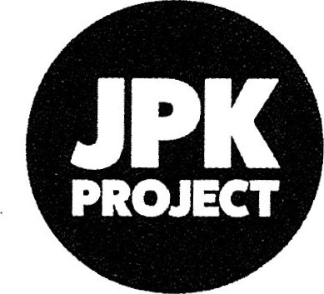Providing Opportunities for People with Learning Disabilities

**NEWSLETTER**

**MARCH 2024**

**Patron: Dame Jane Gow DBE**

**Sponsored by: Ann and Robert Lindsay**

**“Passion is a strong and a barely controllable emotion, which includes strong enthusiasm and sometimes an obsession, to achieve ones aspirations and dreams. The JPK had this ‘passion’ to provide services for people with a learning disability, where they too, could dream their dreams, have aspirations and to live their lives fully within the community. Parent carers too, had a fervency to secure the future for their beloved vulnerable dependents, when they became too old to care or died.**

**In the ‘main stream’ most of our children can’t wait to leave home and live independently, but they have the ability to make these informed choices, but we as parents, have to make these decisions, in the best interest of our vulnerable dependents, before a crisis occurs. This has been hard to handle for us all.**

**It is all well and good having the ‘passion and enthusiasm’ but having endurance and resilience is also key, as nothing in life is easy, as we have found over the years! We faced many hurdles, obstacles and opposition over the years, but we have now reached ‘the end of the tunnel’ with our Supported Living Centre completed (almost)!”**

**THE COMMUNITY TRAINING CENTRE:**

During the months of November, December and January, training continued for our Students, with a two week break over the Christmas period, as the staff chose to close the Café during this time.

The training programs consisted of 7 modules which incorporate:

* Reception
* Table Service
* Barista
* Service Bar
* Food preparation and Wash-up
* Housekeeping
* Food Hygiene – Health & Safety, with all modules incorporating independent Living Skills.

All Students were making great strides in their development and progress.

We had also managed to obtain a work placement for six months for one of students at the Birling Gap Café – National Trust. This has now come to an end and we have referred her to ESCC Supported Employment for further opportunities.

One of our other students has commenced work experience at Birling Gap Café for six months and Jill is currently supporting him. These are two very successful stories.

Initially, the Community Training Centre was supported by The National Lottery Fund for three year funding. This finished 2022 and since then we applied again for a further year’s funding, but were unsuccessful. We also applied to the Henry Smith Fund for three year funding, but sadly were again unsuccessful. It was always intended that the Old Town Café ‘business’ would eventually support this project, but this has never been achieved and has therefore been running at a loss.

**THE OLD TOWN CAFÉ:**

Since the Covid Pandemic the Old Town Café has never really recovered with its custom and with the recent economic downturn and the massive increases in Utility Bills, business has remained low, which has led to the Café running at a loss.

The JPK, by necessity therefore, had been using its reserves, to support these two departments for over two years.

On the 17th January, to remain solvent, the Trustees regretfully had to make the decision to close the Community Training Centre, which also included the Old Town Café from the 19th February. The Trustees met with all the staff on the 19th and sadly had to give them notice. As a measure of good will the Trustees agreed to pay each member of staff an additional weeks pay.

The Trustees main concerns were for the Students, who would be losing their valuable training, work experience and access to the community. ESCC have been notified to address any hardships that may be encountered.

On the same day, a builders van, parked in the JPK Car Park, lost its handbrake and the van ploughed into the entrance doors to the Café!

This necessitated board up the entrance and yet another reason for closing the Café! It ‘never rains but it pours’ for the JPK!

This is a very sad time for so many people, but we are working hard to repairing the entrance doors and looking at all avenues to be able to recommence the training aspects of the project and re-launch the Old Town Café. With this in mind the Trustees have been gradually ‘deep cleaning’ and re-organising the Old Town Café kitchen and restaurant and planning for a future re-launch. ***Watch this space”***

**SUPPORTED LIVING ACCOMMODATION “GOW LODGE”**

At last I can bring you some very good news.

In the October Newsletter we announced the completion of Gow Lodge with its official opening on the 14th September by the Lord Lieutenant of East Sussex, Andrew Blackman, in the presence of the Worshipful the Mayor, Cllr Candy Vaughan, also in the presence of honoured guests, donors, friends, supporters, students, future tenants and families.

Since then Gow Lodge has gone from strength to strength with, a now, full complement of tenants, supported by an excellent MyPesp staff team. There has developed a very happy and active relationship between all the tenants, which is a joy to see and everyone has gradually taken to their new ‘lives’ and new opportunities. Currently work is being undertaken to make an additional en-suite facility for a further tenant.

**Garden Project:**

A further fundraising initiative was commenced in 2023 which was to provide an essential outside space for the tenants of Gow Lodge, for them to enjoy an easily accessible garden for relaxation. This was formed from the upper part of the car park, a difficult undertaking, but we believe that a delightful garden has been achieved, thanks to the support of Claire Ballard and family, the Landscape Gardener, Jack Munro and all those that contributed financially, to this project.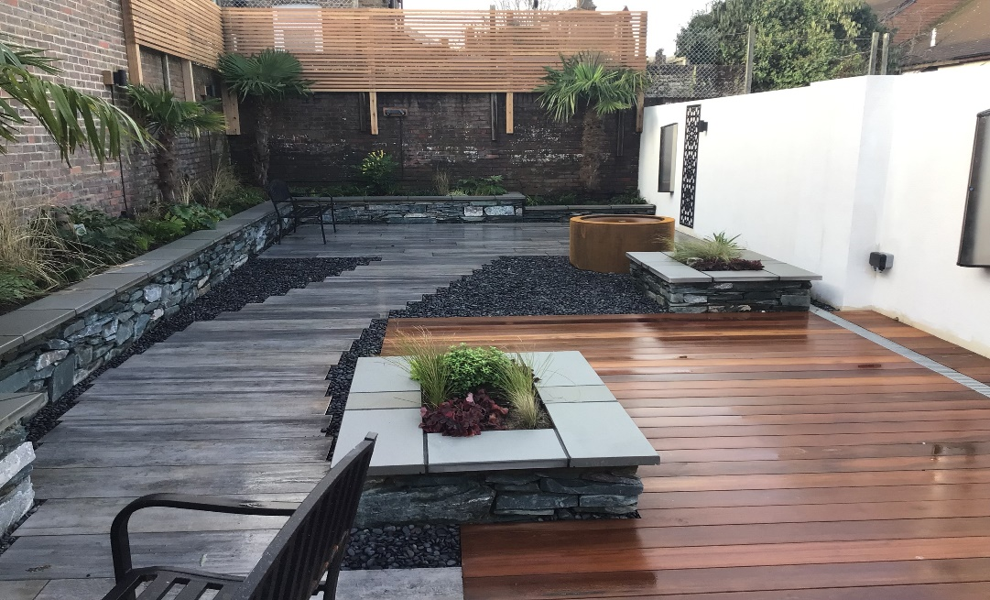

Further fundraising continues to provide the essential furniture for the patio areas, a barbecue and wrought iron gates. A budget has been set for £6,000. We already have donations of £580, a Company who has shown interest in the provision and installation of the gate and a grant application has been sent to Willingdon and Jevington Parish Council with fundraising events being organised. It would be wonderful if everything can be purchased in readiness for the Spring, so that the tenants can enjoy this delightful space.

**People Carrier:**

Fundraising continues, but we estimate that we have sufficient funds available for a petrol 5 Seater. Patrick has undertaken an enormous amount of research into the pros and cons of an electric vehicle and the outcome has shown, that currently a petrol vehicle ‘comes top’, due to the increase in maintenance costs and difficulties in obtaining spare parts, higher insurance premiums and the lack of adequate re-charging stations for electric vehicles. We are currently liaising with Luke Watts, Director of MyPesp, Care Provision and Trustee to the JPK, as to his preferred options on the vehicle.

**PATRON:**

Dame Jane Gow DBE continues to be our Patron and we are grateful for her continuing support, advice and interest.

**TRUSTEES:**

The Trustees continue to work tirelessly behind the scenes to benefit the JPK Charity. Each Trustee has a Lead Role on the Board within their levels of expertise and interest.

After years of searching for further suitable Trustees, thanks to the support of Luke Watts, Director to MyPesp, we have recently recruited six new Trustees and Directors. This will be an exciting development as this new ‘breath of air’ into the charity, will be able to take the project forward into the future. A gradual handover is being arranged and on completion the incumbent Trustees will be able to retire.

**FUNDRAISING AND DONATIONS:**

Since the last Newsletter of October 2023 we have received:

**Grant Making Trusts.**

FB Coales No4 Trust People Carrier £1,000.00

Upperton Ward Garden £ 100.00

Awards4All People Carrier £10,00.00

**Further donations have been received from:**

In Memory of Eveline Knapp Garden £345.00

E/B Historic Vehicle Club Garden £500.00

Our Lady of Randsom Garden £500.00

P Honey Sharon Jones

R Bungard A Collins

East Dean&Friston Residents Association E/B Local Lottery

T Deadman PM Cantwell

I Kitt M&N Clive-Matthews

Utility Warehouse M Fusiarska

J Guthrie M Miller

Just Giving D&E Houghton

CF Morley J&T Dunford

S Smith N Page

A&C Whatford P&D Siggs

J&R Bevan PCC Harrietsham

Polegate United Reform Church Easy Fundraising

P Devonshire BA Sinclair

JA Laughton AP Parker

D Fuller J Rose

HE Harries SE Barrow

H Gibson P Knapp

Give as you Live M Welsh

**JPK Collecting Tins.**

The Triangle Co-op £163.00

**Gift Aid:**

We continue to be ever grateful to all our donors who can apply their donations for Gift Aid. It certainly makes a difference at the end of the year. We can also apply all our smaller cash donations, which includes our Collecting Tins, for Gift Aid (GASDS)This again makes an additional difference.

At the end of March we shall be calculating all the donations under our Gift Aid Scheme and submit to HMRC.

If anyone wants to know the amount they have donated from the beginning of April 2023- end of March 2024 for their Tax Returns, please let Jill know and she will furnish you with this information.

**FUNCTIONS AND FUNDRAISING EVENTS:**

**The Annual General Meeting** was held in Friday, 27th October 2023 at the JPK Project Registered Office Address at 7 Wannock Avenue as there were to be very few attendees. There were 7 attendees, which included Trustees and Professionals and 6 apologies.

The business was undertaken smoothly with the Accounts and Chairman’s Annual Report approved, along with all the Officers.

Since then all the reports have been filed with Companies House and the Charity Commission.

We were extremely grateful; to those that took the time to attend.

**Jazmatazz and Curry Evening:** Regretfully this event was cancelled in November due to lack of support, which was thought to be because of the inclement weather and dark evenings, but has been re-arranged for  **Sunday, 23rd June from 6.30 – 7pm start, at The Old Town Café.**

**Tickets at £20 pp.** Do support this event which should be a very professional and entertaining evening. Jazzmatazz will be performing favourite jazz songs for the 1920s to the 1970s.

Tickets available from Jill.

**The JPK Christmas Party with Buffet Supper and Steve’s Disco** for the Students, Tenants and their families on Friday, 8th December from 6.30pm. Everyone enjoyed the evening and were up dancing and the opportunity to meet Father Christmas (if he was available!) Thankfully, he was and everyone was delighted to meet him (again) and receive a gift.

**Christmas Lunch with the 4Tunes** was held on Friday 15th December at the Old Town Café.

Regretfully numbers were very low but those that did attend enjoyed a delicious Christmas Lunch and wonderful Festive Entertainment from the 4Tunes, which led to everyone getting into the Christmas Spirit. Our Grateful thanks to the 4Tunes

**FUTURE FUNDRAISING EVENT:**

**Jazzmatazz and Curry Evening:**

**Sunday, 23rd June from 6.30 – 7pm start at The Old Town Café.**

**Tickets at £20 pp. Do support this event which should be a very professional and entertaining evening. Jazzmatazz will be performing favourite jazz songs from the 1920s to the 1970s.**

**Tickets available from Jill.**

**SUPPORT** **INFORMATION:**

**Easy Fundraising Website:**

If you shop on line, you can also donate to the JPK by registering with http://www.easyfundraising.org.uk/find-a-cause and select JPK Project. In the search box enter **JPK** – click on **support this cause** and set up the account. A wide range of outlets such as Amazon and John Lewis etc will donate a small % of the purchase price. It doesn’t cost you anything but benefits the JPK.

**Give as you Live:**

This site was brought to our attention recently by one of our supporters as being another avenue of fundraising when using ‘on line’ shopping. Thank you. It costs the JPK and you nothing. Bonus!

**UW Customer Donations:** Everyone who receives their utilities from Utility Warehouse can nominate a charity to benefit and the JPK receive a donation on a monthly basis.

**Used Stamps:**

Una Genty continues to collect used stamps from all and sundry and has recently completed a full bag to send off, whereby we should be receiving a cheque shortly.

Do continue to collect your stamps for us and they can be delivered to Una, if you know her address, through the letterbox at the JPK – Old Town Café- or to Jill.

**Used Ink Cartridges:**

We have been extremely grateful to Jenny Frampton who has for many years collected our used cartridges from which we have received donations.

Regretfully, Jenny can no longer assist with her past fundraising on our behalf, but we are extremely grateful for her support over the years.

**Eastbourne Lottery:**

The JPK has subscribed for many years to the Eastbourne Lottery and we continue to subscribe and are extremely grateful to all those that have purchased tickets on behalf of the JPK. We receive periodic donations from this source which we welcome and are grateful.

**Data Protection:**

Should you no longer wish to be on our mailing list for Newsletters or Information, either by email or ‘snail mail’, please contact us and we will delete your contact details from our database. May I assure you that we never pass on any contact details without your personal confirmation that we may so do.

**Marketing/Website:**

* **Marketing.** Currently we have no one helping us in this department. Should you know of anyone who could spare an hour or two regarding this issue, please do not hesitate to contact Jill.
* **Website:** Regretfully, for several months we have been without a website, as it was illegally removed. However, we are now grateful to Jason Ansell, from MyPesp who has designed a completely new website which I believe is very up to date and refreshing. I still have some more information to add, when I have a moment to spare, but it is a wonderful start.

**Graphic Design:**

Mick Cooke continues to assist the JPK with all our graphic design when required for posters, fliers, invitations and tickets and everything I ask of him on a voluntary basis. He also comes up with some brilliant ideas, from time to time, for raising the profile of the JPK. Thank you Mick for you longstanding and continuing support.

**IN SUMMARY AND CONCLUSION:**

As per usual, there have been some ‘up and downs’ in this Newsletter! No change there, I hear you say!

It has therefore brought the current Trustees into deep discussions to plan the future for the JPK charity. The two ‘Projects’, that being all the development work for the Community Training Centre and Gow Lodge have now been completed. The Garden Area has been completed, with just the furniture, bbq and gates’ fundraising, to complete and the people carrier has almost all the funding required to purchase.

The Trustees, Jill, Patrick and Christine have been in these positions for 20, 20 and 5 years respectively. In addition, Jill has been planning for her ‘exit strategy’ as a Trustee and as Chairman for several years, but it never seemed the right time and being too busy. Without new Trustees, ‘in the wings’, to whom could I possibly hand over, who would have the same aims and objectives as the current Trustees.

From experience I knew this would be difficult, as we had been searching for years for a Care Provider, with experience, ‘a heart’ and not just profit at the forefront.

After several long discussions with Luke Watts, Director, MyPesp, it has been agreed that the JPK Charity will be managed by MyPesp, as a separate charitable entity but under their umbrella. 6 new Trustees and Directors have been appointed by the current Trustees and they have been filed with the Charity Commission and Companies House. New signatories are currently being arranged and there will then commence a ‘slow but sure’ transfer. The new Trustees are already looking at ways to re-launch the Community Training Centre.

The above arrangements are essential for the continuation of the JPK Sussex Project Charity, but for it to continue, it requires ‘young blood’ and a new ‘breath of fresh air’ for it to flourish and progress. We are confident that ‘the new JPK’ will succeed as they have same beliefs and aims to provide excellent care and a superlative life and opportunities for people with a learning disability.

**MyPesp and the new Trustees for the JPK Sussex Project, also have the ‘Passion’ to always improve services for the learning disabled and the ‘Resilience’ to overcome any hurdles, which they may face in the future.**

**We now look to the future and your continuing support**

**.**

***Jill Parker MBE Chairman –*** *not for much longer!!!!*

***Editor***